Configure Hibernate in Eclipse IDE.

Create cfg.xml file

<?**xml** version=*"1.0"* encoding=*"UTF-8"*?>

<!**DOCTYPE** hibernate-configuration SYSTEM " http://www.hibernate.org/dtd/hibernate-configuration-3.0.dtd">

<**hibernate-configuration**>

<**session-factory**>

<**property** name=*"hibernate.dialect"*> org.hibernate.dialect.MySQL5Dialect</**property**>

<**property** name=*"hibernate.connection.driver_class"*> com.mysql.cj.jdbc.Driver</**property**>

<**property** name=*"hibernate.connection.url"*> jdbc:mysql://localhost:3306/mphasis</**property**>

<**property** name=*"hibernate.connection.username"*> root </**property**>

<**property** name=*"hibernate.connection.password"*> sonikaSHETTY#17 </**property**>

<**property** name=*"show_sql"*> true </**property**>

<**property** name=*"hbm2ddl.auto"*> update </**property**>

<**mapping** class=*"com.entities.Books"*/>

</**session-factory**>

</**hibernate-configuration**>

**Add Jar files**

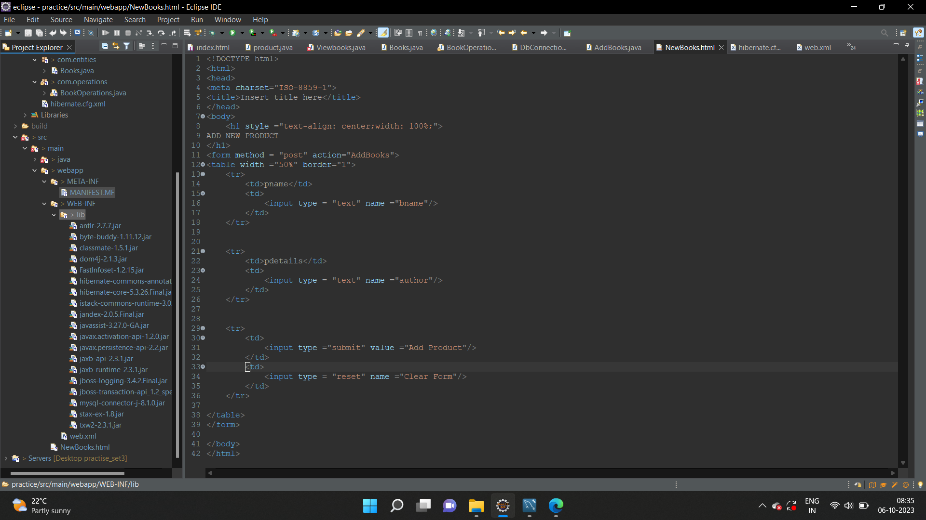

Add Servlet jar in build path

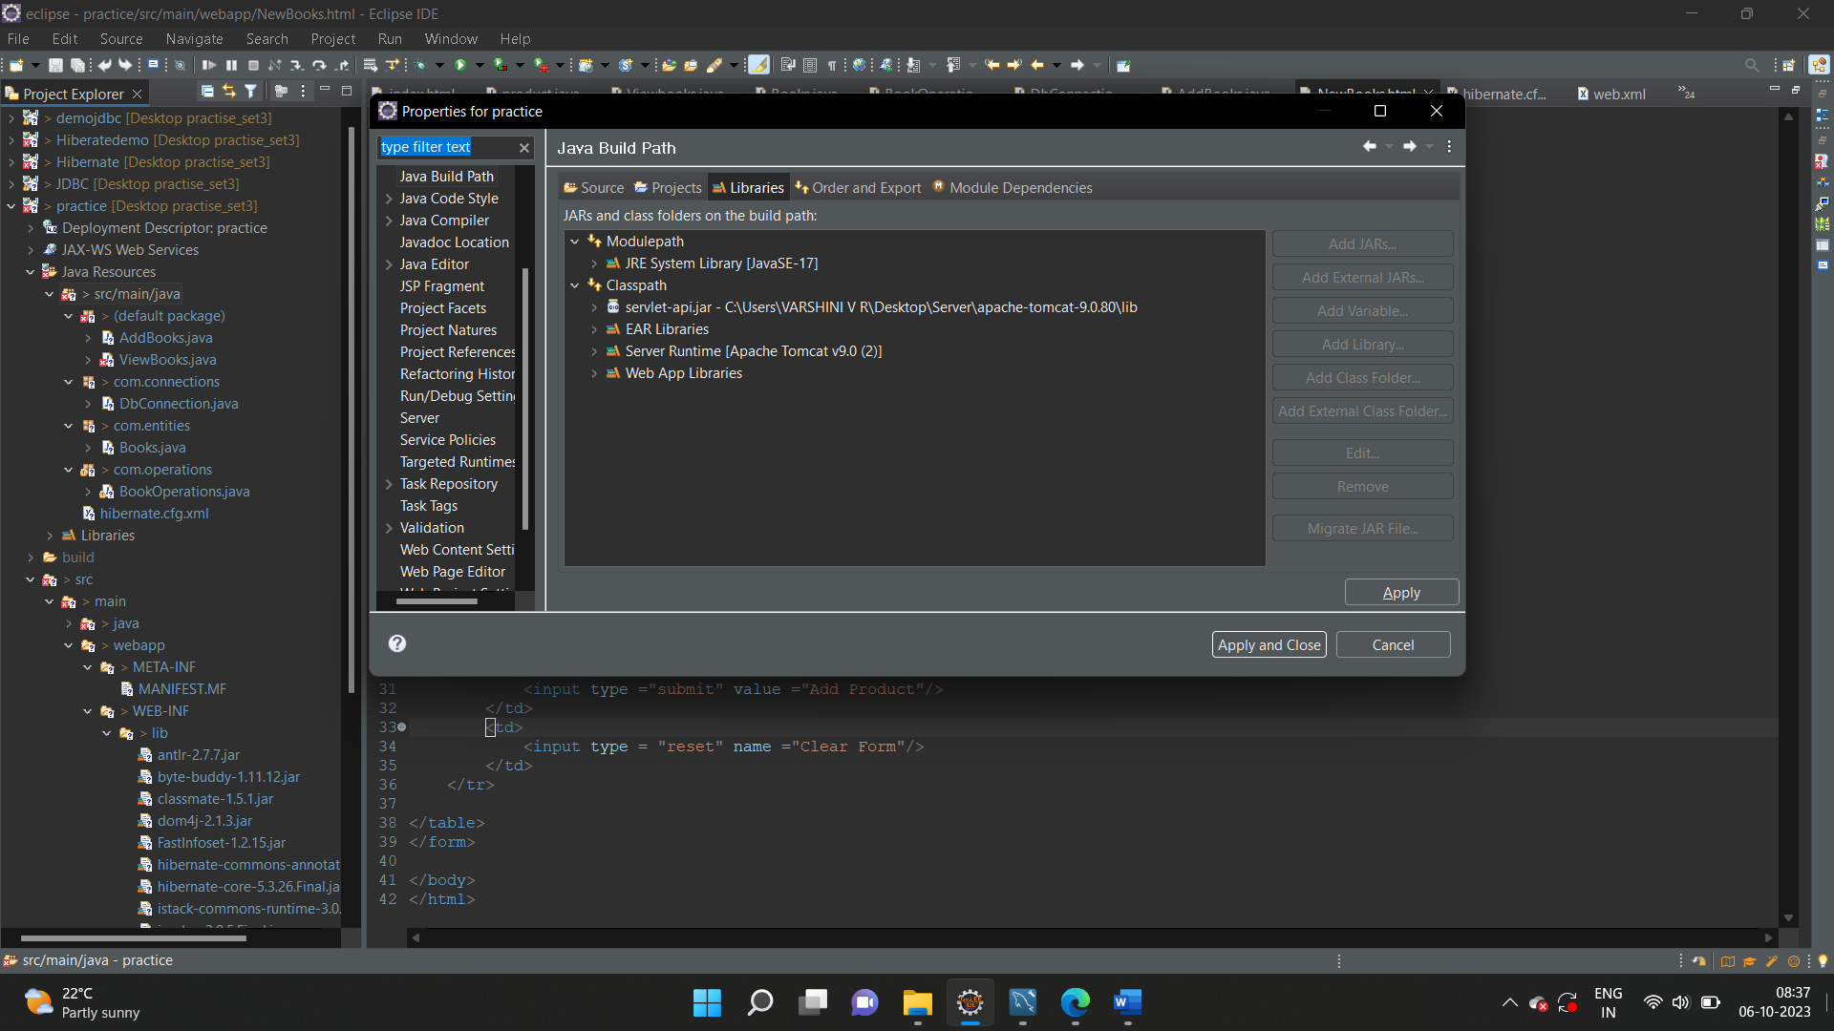

Create a Class

package com.entities;

import javax.persistence.Column;

import javax.persistence.Entity;

import javax.persistence.GeneratedValue;

import javax.persistence.Id;

import javax.persistence.Table;

@Entity

@Table(name="bookinfo")

public class Books {

@Id

@GeneratedValue

@Column(name="pno")

private int bookno;

@Column(name="pname")

private String bookname;

@Column(name="pdetails")

private String author;

public int getBookno() {

return bookno;

}

public void setBookno(int bookno) {

this.bookno = bookno;

}

public String getBookname() {

return bookname;

}

public void setBookname(String bookname) {

this.bookname = bookname;

}

public String getAuthor() {

return author;

}

public void setAuthor(String author) {

this.author = author;

}

}

Create a operation class

package com.operations;

import java.util.List;

import javax.persistence.TypedQuery;

import org.hibernate.Session;

import org.hibernate.SessionFactory;

import org.hibernate.Transaction;

import com.connections.DbConnection;

import com.entities.Books;

public class BookOperations {

private SessionFactory sfact = null;

public BookOperations()

{

sfact = DbConnection.getConnection();

}

public void AddBooks(Books book)

{

Session session = sfact.openSession();

Transaction trans = session.beginTransaction();

session.save(book);

trans.commit();

session.close();

}

}

Create connection

package com.connections;

import org.hibernate.SessionFactory;

import org.hibernate.cfg.Configuration;

public class DbConnection {

public static SessionFactory getConnection()

{

Configuration cfg = new Configuration();

cfg.configure("hibernate.cfg.xml");

SessionFactory sf = cfg.buildSessionFactory();

return sf;

}

}

Create Servlet

import java.io.IOException;

import java.io.PrintWriter;

import javax.servlet.ServletException;

import javax.servlet.annotation.WebServlet;

import javax.servlet.http.HttpServlet;

import javax.servlet.http.HttpServletRequest;

import javax.servlet.http.HttpServletResponse;

import com.entities.Books;

import com.operations.BookOperations;

/**

* Servlet implementation class AddBooks

*/

*@WebServlet*("/AddBooks")

public class AddBooks extends HttpServlet {

private static final long ***serialVersionUID*** = 1L;

/**

* **@see** HttpServlet#HttpServlet()

*/

public AddBooks() {

super();

// **TODO** Auto-generated constructor stub

}

/**

* **@see** HttpServlet#service(HttpServletRequest request, HttpServletResponse response)

*/

protected void service(HttpServletRequest request, HttpServletResponse response) throws ServletException, IOException {

// **TODO** Auto-generated method stub

String bname = request.getParameter("bname");

String author = request.getParameter("author");

Books book = new Books();

book.setBookname(bname);

book.setAuthor(author);

BookOperations bop = new BookOperations();

bop.AddBooks(book);

response.setContentType("text/html");

PrintWriter out = response.getWriter();

out.print("<h2>PRODUCT Added....</h2>");

request.getRequestDispatcher("NewBooks.html").include(request, response);

}

}

Create HTML page

<!DOCTYPE html>

<html>

<head>

<meta charset="ISO-8859-1">

<title>Insert title here</title>

</head>

<body>

<h1 style ="text-align: center;width: 100%;">

ADD NEW PRODUCT

</h1>

<form method = "post" action="AddBooks">

<table width ="50%" border="1">

<tr>

<td>pname</td>

<td>

<input type = "text" name ="bname"/>

</td>

</tr>

<tr>

<td>pdetails</td>

<td>

<input type = "text" name ="author"/>

</td>

</tr>

<tr>

<td>

<input type ="submit" value ="Add Product"/>

</td>

<td>

<input type = "reset" name ="Clear Form"/>

</td>

</tr>

</table>

</form>

</body>

</html>